**GANIPINENI SOWMYA**

**700747116**

**ASSIGNMENT 3**

**NEURAL NETWORKS AND DEEP LEARNING**

1. Create a class Employee and then do the following • Create a data member to count the number of Employees • Create a constructor to initialize name, family, salary, department • Create a function to average salary • Create a Fulltime Employee class and it should inherit the properties of Employee class • Create the instances of Fulltime Employee class and Employee class and call their member functions.

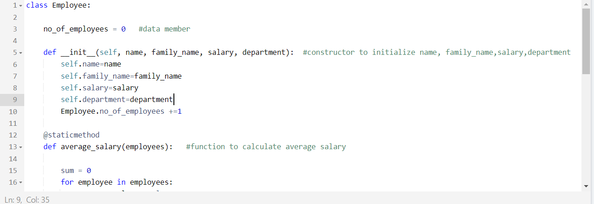

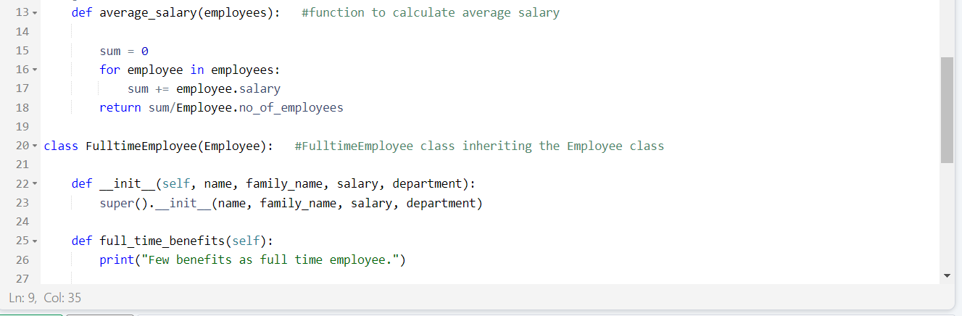

**Output:**

1. **Numpy**



